BIT235 - Object Oriented Programming (OOP)

Workshop 2

Fundamental Programming Structures in Java
Variables – Primitive Datatypes and String

After completing writing your java programs, Create a new Github repository “BIT235Workshop2” Push from VS Code or Upload them in your GitHub repository and provide the link here, Make sure your repository is “Public” so that I can check your code there.
GitHub Link:

Exercise 1.1 | Write a java program to display the result of difference of two numbers.  A user will enter two integers (import Scanner)  Program will calculate their difference  Program then display the result  Answer: 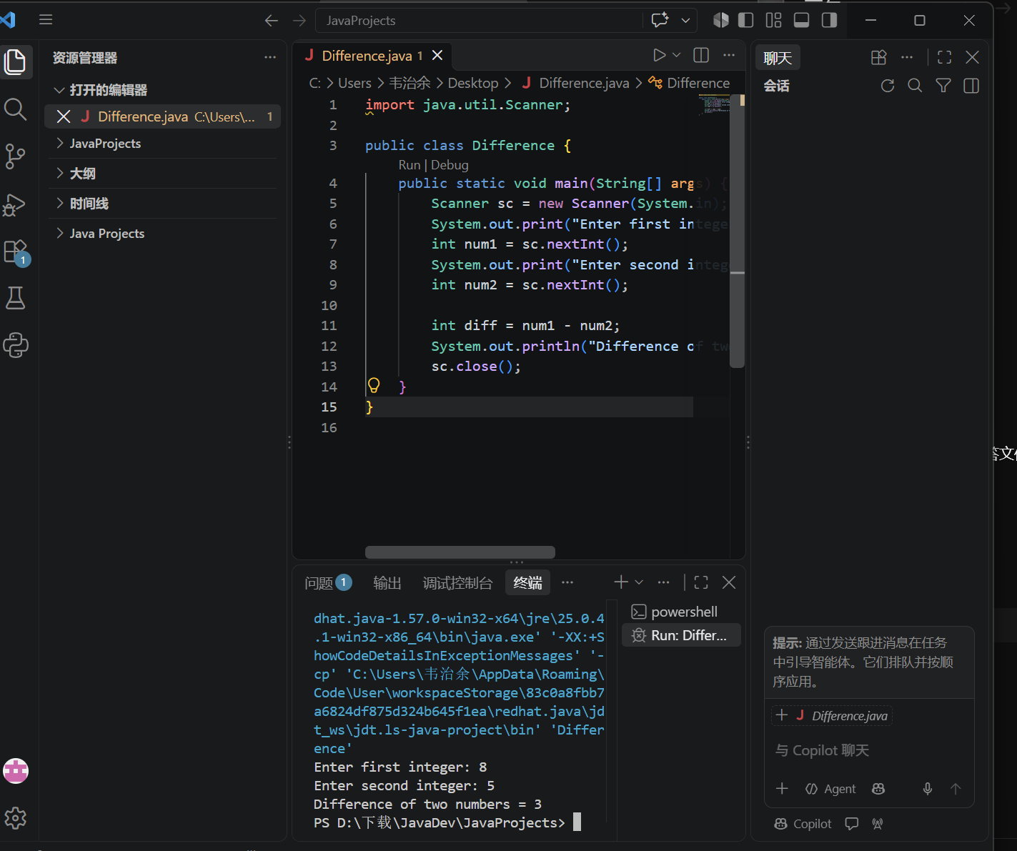
Exercise 1.2 | Write a Java program covered in class to convert degrees Celsius to degrees Fahrenheit.  Hint: Use the formula F = C*9/5 + 32  Answer: 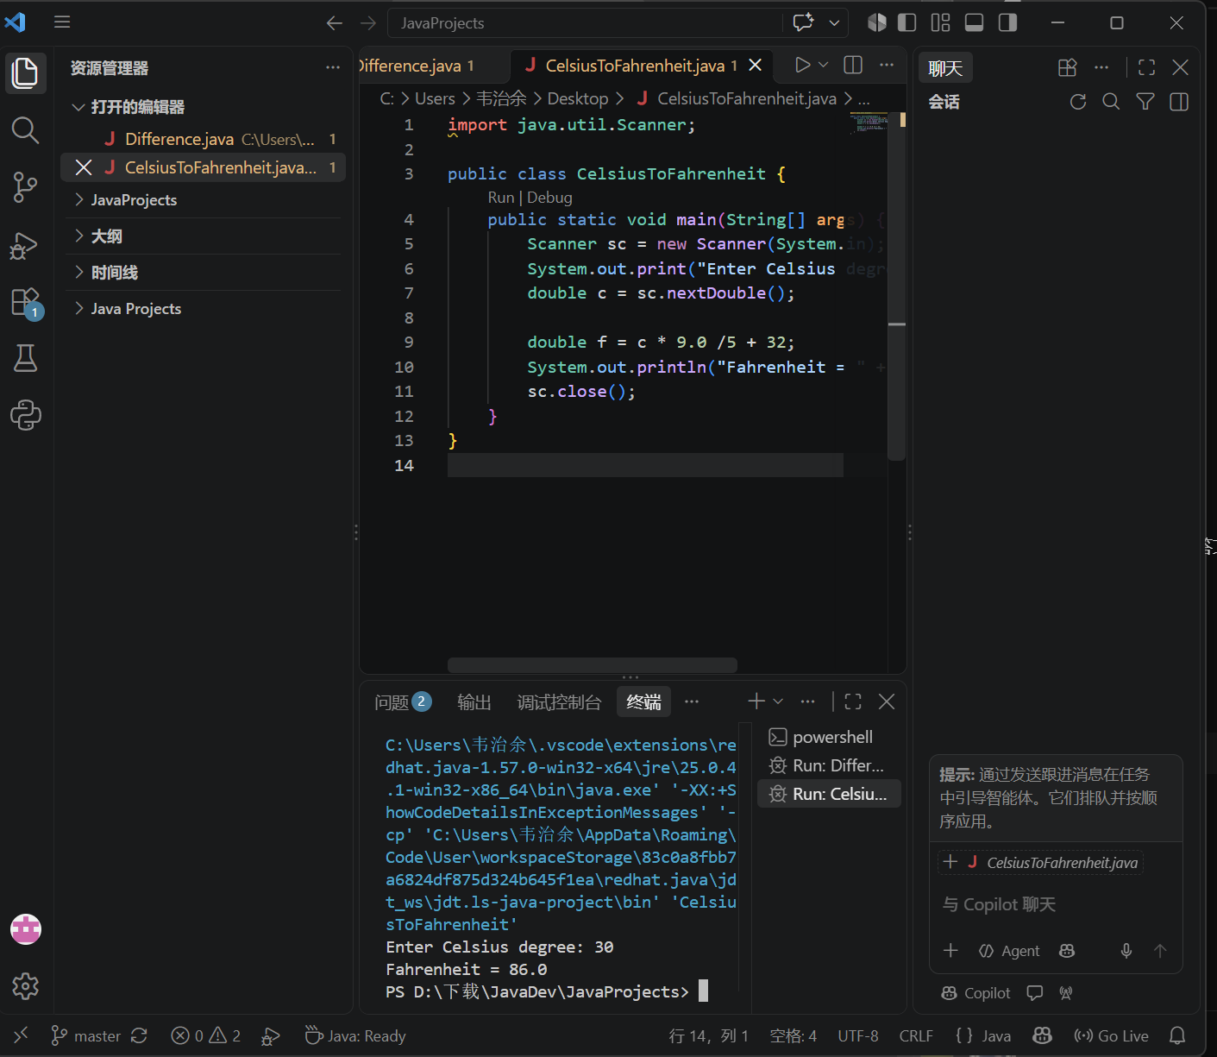
Exercise 1.3 | Write a Java program to calculate the area of a circle. Recall that the area of circle is given by  Area = (pi)*radius*radius (i.e. pi * r²). Try it with several different values for the radius and use 3.14 for pi.  Hint : To calculate square use Java method Math.pow(i, 2), which is equivalent of i²;  Answer: 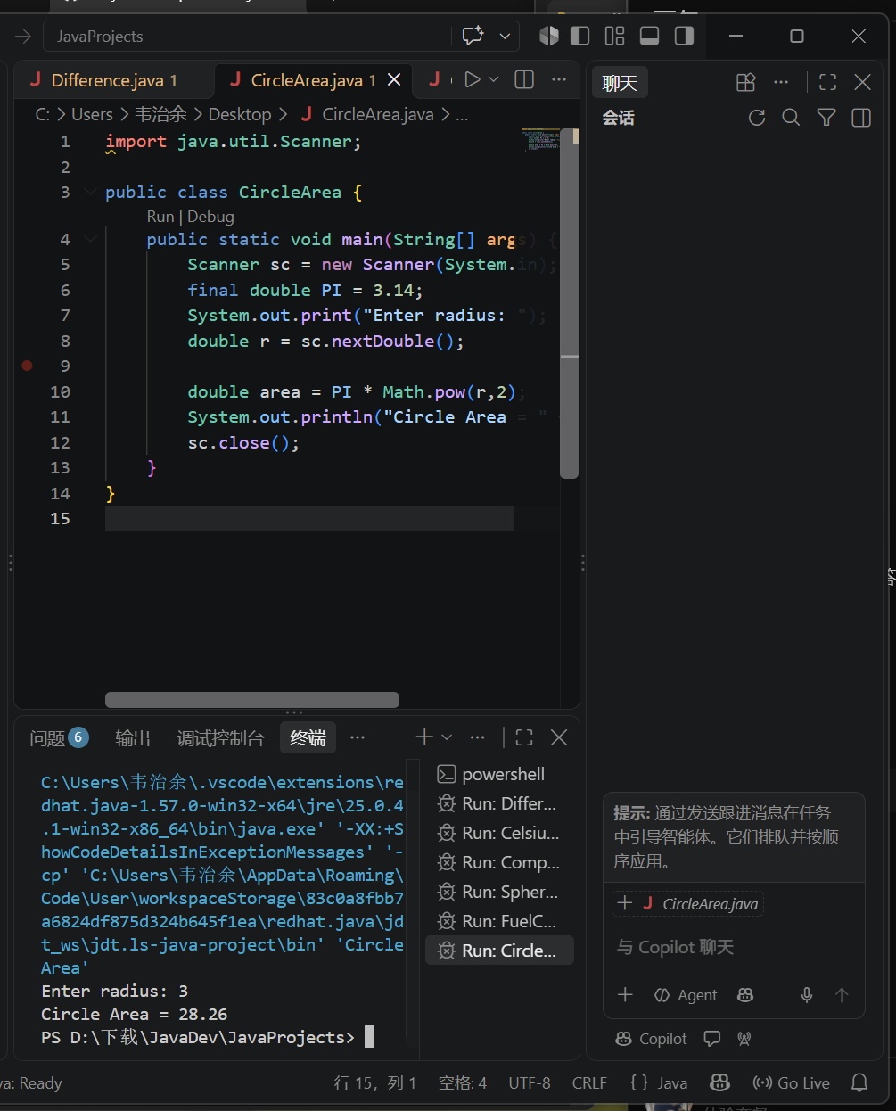
Exercise 1.4 | Compound Interest. Using the compound Interest Formula  A = P * (1 + r)^{n}  where A is the amount, r is the interest rate per time period, and n is the number of time periods.  Write a Java program to calculate and display the result where  P= $ 5000.00 investment ; r = 4% interest rate per year ; n = 10 years.  Hint : To calculate power multipliers, use Java method Math.pow(i, n), which is equivalent of i^{n};  Answer: 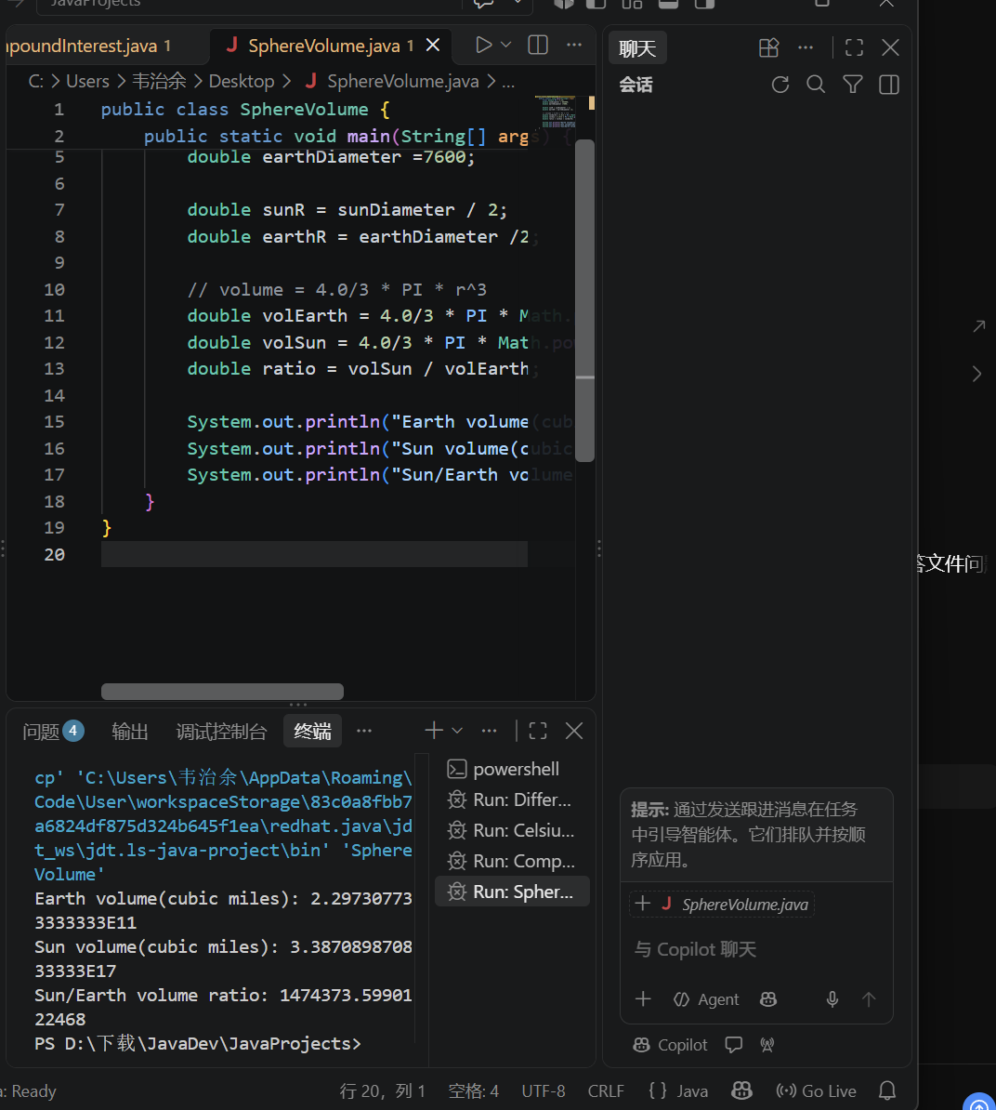
Exercise 1.5 | The diameter of the Sun is approximately 865,000 miles. The diameter of the earth is approximately 7,600 miles.  Use the methods in Math class to write a Java program calculate and display:  a.) The volume of the Earth in cubic miles.  b.) The volume of the Sun in cubic miles.  c.) The ratio of the Sun to the volume of the Earth.  Volume of sphere = (4/3) * pi * r³  where r = radius = diameter/2  and pi = 3.14  Hint : To calculate cube, use Java method Math.pow(i, 3), which is equivalent of i³;  Answer:  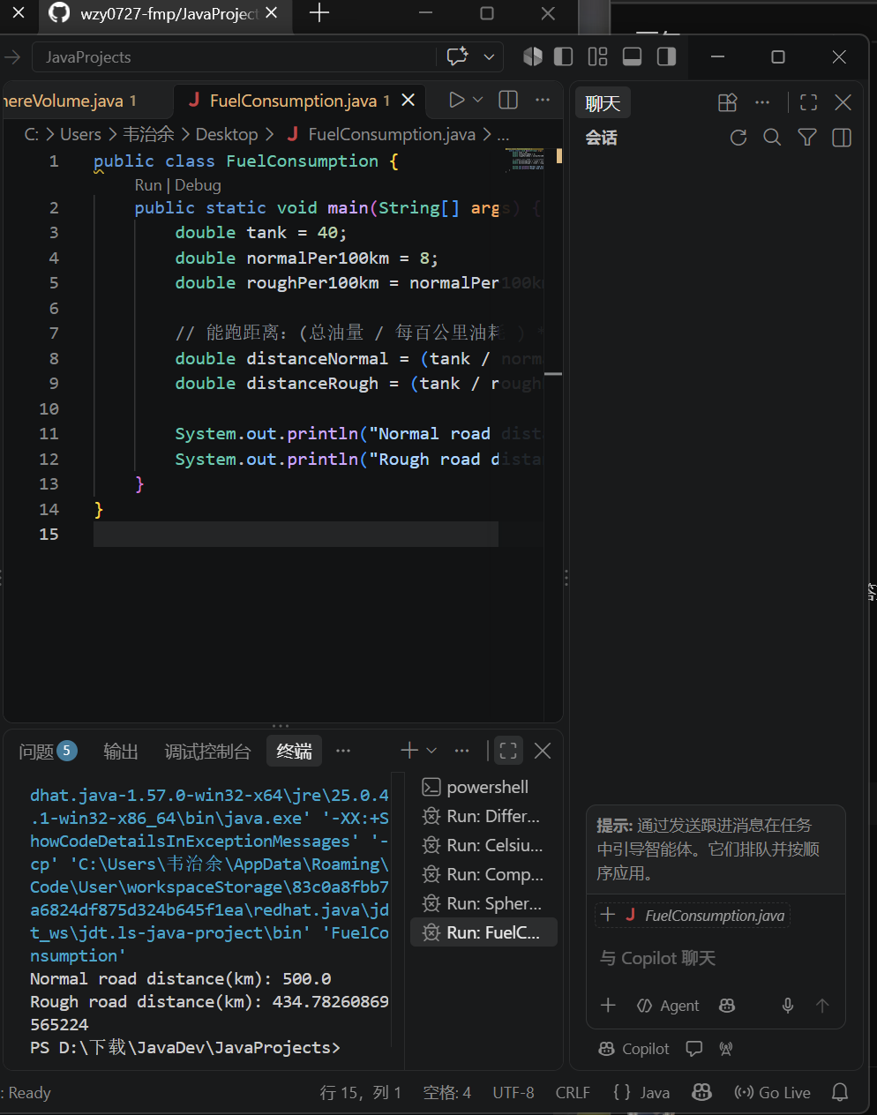
Exercise 1.6 | Fuel consumption. A motor car use 8 liters of fuel per 100 kilometers of normal road and 15% more fuel on rough roads. Write a Java program to calculate and display the distance the car can travel on a full tank of 40 liters of fuel on both normal and rough roads.  Answer:

Exercise 1.7 | How long is the string returned by the following expression? What is the string?  "I love java programming".substring(7, 11);  Answer: String returned: java；Length: 4
Exercise 1.8 | Write a program that compares two strings.  A user will enter two Strings ( import Scanner)  Program will compares both strings  Program then display the result “the two given strings are equal” True/False based on the comparison.  Program will also compare the first character of each String.  Hint: Use equals(Object anObject) method and charAt(int index)  Answer:  